* Base Network Address: 192.168.40.0

No of subnets = No of departments 🡺2

* 2^n = 2

N=1 🡺 no of bits changed = 1

* 255.255.255.255:

11111111.11111111.11111111.11111111

* Since one bit must be changed:

11111111.11111111.111111111.10000000 🡺 255.255.255.128

* Subnet mask: 255.255.255.128

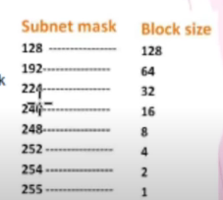

* 1st subnet:

Subnet mask: 255.255.255.128

Network ID: 192.168.40.0

Range of Valid hosts: 192.168.40.1 – 192.168.40.126

Broadcast ID: 192.168.40.127

[Since the block size is 128 and the network id starts from 0, it must end at 127 to make it 128]

* 2nd subnet:

Subnet mask: 255.255.255.128

Network ID: 192.168.40.128 [the next bit from the broadcast of first subnet]

Range of Valid hosts: 192.168.40.129 – 192.168.40.254

Broadcast ID: 192.168.40.255

[Since the block size is 128 and the network id starts from 128, it must end at 255 to make it 128]

* The slash notation for subnet mask is obtained by counting the number of ones in the subnet mask. In this example, the subnet mask can be represented as 192.168.40.0/25 (8+8+8+1) and 192.168.40.128/25.